Homework Two
Problem one:
(1) Condition:
This program can calculate and research followed this math function:
V I N G T
C I N Q
+ C I N Q
--------------
T R E N T E
Each letter represents a decimal number! But these letter that V and C and T are not number value of 0. In other words, their range are all 1 to 9. The remainder numbers of range of I, N, G, Q, R are 0 to 9, Please find out the number values which accord with above-mentioned conditions!
(2) Program code (guess_bad.c ):
----------------------------------------------------------Program code start----------------------------------------------------------
#include<stdio.h>
#include<stdlib.h>
#include<time.h>
int main()
{
short v,c,t,i,n,g,q,r,e,equ_det; /*Declar nine number and an equal determine register.*/
int start_time, end_time; /*Declar register that record start and end running time*/
printf("\n---------------∮This program is-★-B9502028-★-陳敬翔-create∮---------------\nThis program can calculate :\n V I N G T\n C I N Q\n + C I N Q\n -----------\n T R E N T E\nPlease enter any key to start!\n");
getch();
printf("\nStart! Calculating...\n\n");
start_time=clock(); /*Record star time.*/
for(v=1;v<=9;v++)
{
for(c=1;c<=9;c++)
{
for(t=1;t<=9;t++)
{
for(i=0;i<=9;i++)
{
for(n=0;n<=9;n++)
{
for(g=0;g<=9;g++)
{
for(q=0;q<=9;q++)
{
for(r=0;r<=9;r++)
{
for(e=0;e<=9;e++)
{
/*Determine whether there is equal toing value.If equal,then equ_det=1,else equ_det=0*/
if((v!=c)&&(v!=t)&&(v!=i)&&(v!=n)&&(v!=g)&&(v!=q)&&(v!=r)&&(v!=e)&&(c!=t)&&(c!=i)&&(c!=n)&&(c!=g)&&(c!=q)&&(c!=r)&&(c!=e)&&(t!=i)&&(t!=n)&&(t!=g)&&(t!=q)&&(t!=r)&&(t!=e)&&(i!=n)&&(i!=g)&&(i!=q)&&(i!=r)&&(i!=e)&&(n!=g)&&(n!=q)&&(n!=r)&&(n!=e)&&(g!=q)&&(g!=r)&&(g!=e)&&(q!=r)&&(q!=e)&&(r!=e))
{
equ_det=0;
}
else
{
equ_det=1;
}
/*calculate VINGT + CINQ + CINQ is or is'nt TRENTE*/
if((equ_det==0)&&((v*10000+i*1000+n*100+g*10+t)+2*(c*1000+i*100+n*10+q)==(t*100000+r*10000+e*1000+n*100+t*10+e)))
{
/*Print the result and */
printf("V = %d , C = %d , T = %d , I = %d , N = %d , G = %d , Q = %d , R = %d , E = %d\n V I N G T %d %d %d %d %d\n C I N Q %d %d %d %d\n+ C I N Q + %d %d %d %d\n----------- -----------\nT R E N T E %d %d %d %d %d %d",v,c,t,i,n,g,q,r,e,v,i,n,g,t,c,i,n,q,c,i,n,q,t,r,e,n,t,e);
}
}
}
}
}
}
}
}
}
}
end_time=clock();/*Record end time.*/
printf("\n\nEnd!\nRunning time is %.3f second",(float)(end_time-start_time)/CLOCKS_PER_SEC);/*Print difference that star time and end time,*/
getch();
return 0;
}
----------------------------------------------------------Program code end----------------------------------------------------------
(3) Executing result:
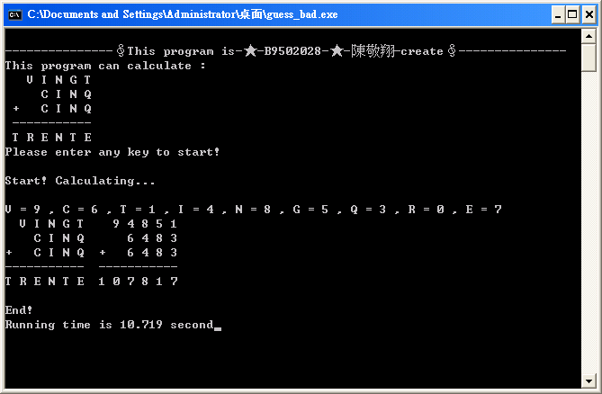
(4) Explane and discuss:
It find a result, but its execution time is very slow, unexpectedly it took 10.719 seconds, then in order to increase the speed that will be execution soon, probe into its principle, we can find some rules , in fact some loop are unnecessary to run too many times!
So we join some conditions to limit:
Ⅰ、Because “ I + C + C ” is the biggest smaller than 27, at the same time it is 11 that “ V + carry “ (2 or 1 or 0 ) are the biggest, so T must be 1.
Ⅱ、If “ V + carry “ should have a carry, V it must be 8 or 9, at the same time, R must be 0 or 1, since T is 1, R it have to be 0.
Ⅲ、” Q + Q + T = Q + Q + 1 == E ”, so E must be a odd number.
Ⅳ、 ” I + I + N + carry == N ”, carry can be 0 , 1 or 2, so “ I + I + carry == 10 or 20 ”, therefore can know that I must be 4 or 5 or 9
(5) Modify program code (guess.c ):
----------------------------------------------------------Program code start----------------------------------------------------------
#include<stdio.h>
#include<stdlib.h>
#include<time.h>
int main()
{
short v,c,t,i,n,g,q,r,e,equ_det; /*Declar nine number and an equal determine register.*/
int start_time,end_time; /*Declar register that record start and end running time*/
printf("\n---------------∮This program is-★-B9502028-★-陳敬翔-create∮---------------\nThis program can calculate :\n V I N G T\n C I N Q\n + C I N Q\n -----------\n T R E N T E\nPlease enter any key to start!\n");
getch();
printf("\nStart! Calculating...\n\n");
start_time=clock(); /*Record star time.*/
for(v=1;v<=9;v++)
{
for(c=1;c<=9;c++)
{
for(t=1;/*t<=9*/t<=1;t++) /*Modify rule Ⅰ*/
{
for(i=0;/*i<=9*/i<9; /*i++*/)/*Modify ruleⅣ*/
{
if(i==5)
{
i=9;
}
if(i==4)
{
i=5;
}
if(i==0)
{
i=4;
}
for(n=0;n<=9;n++)
{
for(g=0;g<=9;g++)
{
for(q=0;q<=9;q++)
{
for(r=0;/*r<=9*/r<=0;r++) /*Modify rule Ⅱ*/
{
for(/*e=0*/e=1;e<=9;/*e++*/e=e+2) /*Modify ruleⅢ*/
{
/*Determine whether there is equal toing value.If equal,then equ_det=1,else equ_det=0*/
if((v!=c)&&(v!=t)&&(v!=i)&&(v!=n)&&(v!=g)&&(v!=q)&&(v!=r)&&(v!=e)&&(c!=t)&&(c!=i)&&(c!=n)&&(c!=g)&&(c!=q)&&(c!=r)&&(c!=e)&&(t!=i)&&(t!=n)&&(t!=g)&&(t!=q)&&(t!=r)&&(t!=e)&&(i!=n)&&(i!=g)&&(i!=q)&&(i!=r)&&(i!=e)&&(n!=g)&&(n!=q)&&(n!=r)&&(n!=e)&&(g!=q)&&(g!=r)&&(g!=e)&&(q!=r)&&(q!=e)&&(r!=e))
{
equ_det=0;
}
else
{
equ_det=1;
}
/*calculate VINGT + CINQ + CINQ is or is'nt TRENTE*/
if((equ_det==0)&&((v*10000+i*1000+n*100+g*10+t)+2*(c*1000+i*100+n*10+q)==(t*100000+r*10000+e*1000+n*100+t*10+e)))
{
/*Print the result and */
printf("V = %d , C = %d , T = %d , I = %d , N = %d , G = %d , Q = %d , R = %d , E = %d\n V I N G T %d %d %d %d %d\n C I N Q %d %d %d %d\n+ C I N Q + %d %d %d %d\n----------- -----------\nT R E N T E %d %d %d %d %d %d",v,c,t,i,n,g,q,r,e,v,i,n,g,t,c,i,n,q,c,i,n,q,t,r,e,n,t,e);
}
}
}
}
}
}
}
}
}
}
end_time=clock();/*Record end time.*/
printf("\n\nEnd!\nRunning time is %.3f second",(float)(end_time-start_time)/CLOCKS_PER_SEC);/*Print difference that star time and end time,*/
getch();
return 0;
}
----------------------------------------------------------Program code end----------------------------------------------------------
(6) Modify program executing result:
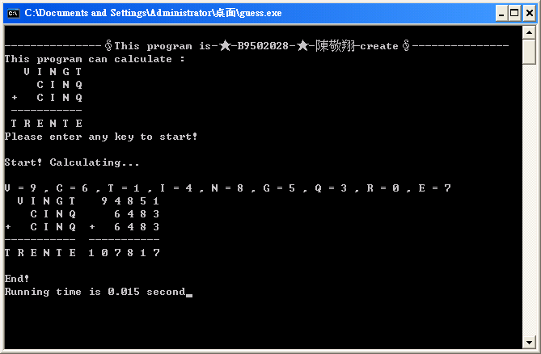
(7) Result:
Program modify is successful! We reduction the execution time larger! The running time is 0.015 in here!
Problem two:
(1) Condition:
Print out the multiplication table by using “ pointer ”.
(2) Simple program concept code (multiplication_simple.c ):
----------------------------------------------------------Program code start----------------------------------------------------------
#include<stdio.h>
#include<stdlib.h>
int main()
{
short i,j; /*Use the loop " i and j " to control multiplication table.*/
printf("\n---------------∮This program is-★-B9502028-★-陳敬翔-create∮---------------\n\n");
for(i=1;i<=9;i++)
{
for(j=1;j<=9;j++)
{
printf("%d*%d=%2d ",i,j,i*j);
}
printf("\n");
}
getch();
return 0;
}
----------------------------------------------------------Program code end----------------------------------------------------------
(3) Simple program concept executing result:
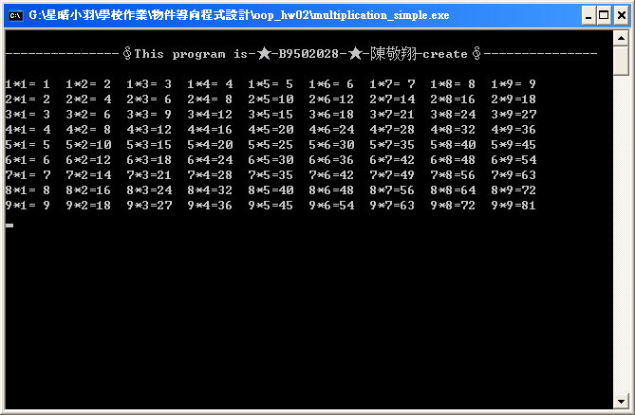
(4) Use pointer to design, we can do it in this way (multiplication.c ):
----------------------------------------------------------Program code start----------------------------------------------------------
#include<stdio.h>
#include<stdlib.h>
int main()
{
short mul[9][9],i,j; /*Use the loop " i and j " to control multiplication table.*/
printf("\n---------------∮This program is-★-B9502028-★-陳敬翔-create∮---------------\n\n");
for(i=0;i<9;i++) /*And we declare a pointer array to reserve the space of main remember recode the result.*/
{
for(j=0;j<9;j++)
{
*(*(mul+i)+j)=(i+1)*(j+1);
}
}
for(i=0;i<9;i++)
{
for(j=0;j<9;j++)
{
printf("%d*%d=%2d ",*(*(mul+i)),*(*(mul+j)),*(*(mul+i)+j)); /*Print the result!*/
}
printf("\n");
}
getch();
return 0;
}
----------------------------------------------------------Program code end----------------------------------------------------------
(3) Executing result:
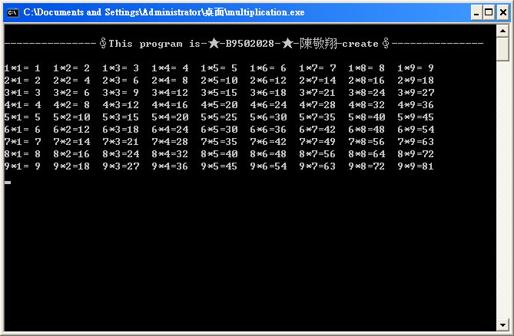
(7) Result:
Make success!

